Game idea:
Two players build up their troops to battle it out in a strategic fight, including Guards, Champions and the King, who should be protected at all times. Take your opponents pieces through Attacks or Skills and win the game with your tactic, but watch out for the other player, he might just have something up his sleeve to turn the tides in his favor.

Goal of the game:
The winner is determined by who can take out the opponent's king first. If every piece except the two kings are gone from the board it is counted as a draw, the same goes for when no piece has been taken in 10 turns.

Components:
- Game Board: The 12x12 game board is made up of 4 terrain types, each you can find the same amount of, which influence the movement range of your pieces, the Champion's Skill range and the armor of the pieces.
- Champions: Both players have 5 Champions on the board at the start, but there are in total 18 Champions of 6 classes to choose from, each having 2 Skills that suit their class and 1 Joker Skill from another class that fits the piece. Every Champion has a terrain that they are good on.
- Guards: Each player also has 6 Guards, which take up a more protective role for the Champions and the King in the game. They are neutral on every terrain.
- King: The King is similar to a Champion, in which he also has his 3 Joker Skills, but he is neutral on every terrain, just like the Guards.
- Skills: Like mentioned before, all the Champions and the king have 3 Skills which they can activate and use during their turn.

Setup:
- Build the game board to your liking, with how you set up the terrain, but make sure that the first 6x6 corner is mirrored correctly, so that every area of the board is balanced and fair for everyone.
- Flip a coin for who goes first.
- Pick and ban phase: Player 1 starts off by banning a Champion they dislike and picking their first two and where they should go on the board, afterwards Player 2 does the same, which gets repeated once more for each player, then Player 1 takes his final Champion and Player 2 does the same. Both sides can take the same Champions, so Player 1’s Champion of type A could fight against Player 2’s Champion of type A, but both players can’t take the same type of Champion twice.
- Each player receives 5 Skill Runes, abbreviated to Runes, at the start of the game.
- Player 1 starts the first turn.

Gameplay:
How a single turn is played:
(GAME NAME) is played in turns, which consist of a movement phase and an action phase. The game starts at turn 1 and then counts up by 0.5 when a player is done with both phases, so a full turn consists of both players having made their respectable actions.

Movement Phase:
During the movement phase, a player has 2 Move Slots. They can use these slots to move up to two different pieces by 1 tile each, in any direction. Terrain can influence these movements, but the minimum movement range is 1. Guards, however, can move up to 2 tiles as long as terrain or injuries don’t hinder them. Players don’t have to use their Move Slots if they choose; they can move just one piece or skip the phase entirely. Additionally, when guards move onto enemy pieces, it’s considered an attack.

Action Phase:
In the action phase a player has 2 Skill Slots at the start of the game, which can be used to activate a Skill like the name implies.

A complete turn comes to an end:
Now that both players have finished their turn they get 1 more Rune. Every 7 turns (7, 14, 21…) this tally increases by 1, so after and including round 7 both players receive 2 Runes and so on. The amount of Skill Slots in the action phase also increases from the starting point of 2, this happens every 10 turns (10, 20, 30…), so after and including round 10 both players can use 3 Skill Slots.

Attack System:
If you move onto a tile that holds an opponent's piece you will take that piece and afterwards move to that space, if not done through a movement skill. If the attacked piece is a Champion, but has a Guard adjacent to it, the Guard is taken instead and you will remain in your current position. If there are more than one Guard the closest one to your piece gets taken and if there is still no decision the one closest to the middle of the board gets taken.

Skill System:
The most complex system in the game is by far the Skill system. A single Skill has 5 different attributes that describe it: Name, Cost, Champion, Class and Effect. When choosing to cast a Skill you first need to check if you can afford to do so, if not you won’t be able to activate it, otherwise you are free to go. Each Champ (and the king) has 3 Skills: 2 that are of the Champs Class and 1 from another Class. The standard Skill range is 2, except the king’s who’s is 3, which is affected by the terrain the Champ stands on, going up or down by 1. Some Skills may affect this as well. This is further explained in the champion classes part.

Health System:
All Pieces have 2 States they can be in: Normal and Injured, so if 1 DMG is dealt it gets injured, an additional 1 DMG hit will remove the piece from the board. If a piece is injured, its movement is capped at 1 and the skill range is reduced by 1. This is the damage chart:
Attack - 2 DMG | Offense Skill - 1 DMG | (When the Effect is of the damaging type) Terrain Effect - 1 DMG when: stepped on by a piece, casted on a piece or the piece's turn ends whilst standing on it. Pieces can also be healed from being injured as well as getting armor that can stack, which prevents 1 DMG for each armor point a piece has. Receiving armor when injured will not stop the injured effects from affecting the piece. 3 Armor is the maximum.

Champion Classes:
Champs are of 6 different classes that change their basic use. Each class holds 3 different champions that still vary from their specific uses inside the class scope.
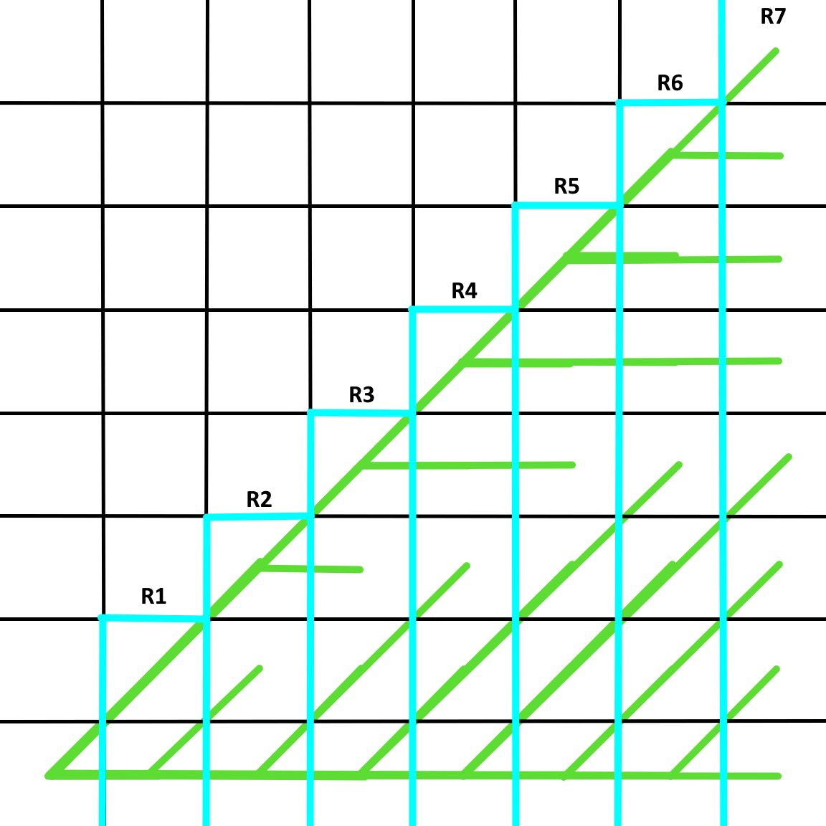
Offense - These Champs are attackers, whose main target is dealing damage directly. Their skills are used to damage opponent pieces by 1, unless affected by something that ups it. Offense Skills can also be intercepted by Guards, so a Champion standing behind one can’t be hit, at least by offense skills. There are a few rules on how the Skill path is determined:

You pretty much stay either diagonally or in a straight line, until you have to branch off to reach your destination, the straight line being preferred. The Skill path is only used for Offense Skills or when pieces are being moved by any other skill, so they trace along a certain amount toward a target.

The base cost of an Offense Skill is 2, which will go up by 1 when the Champion has an extra effect on top of damaging the targeted piece.

Mobility - Mobility Champions are used to move around pieces on the board. This has many offensive or defensive use cases. You need to mention that you can’t use this movement as an attack by moving for example a guard onto an opponent's piece. Each Mobility Skill handles full target squares differently, so there aren’t default rules in place. Mobility Skills are also given an additional range to boost usability.

Boost - The role is pretty straightforward: give effects, buffs or similar to your pieces. This can include healing injuries, or just adding armor.

Defense - Defensive Champions have the important role of preventing the need of having a healer. Defense Skills have three variants:
Weak Shield - 2 Rounds - 1 DMG absorb
Strong Shield - 2 Rounds - 2 DMG absorb
Mirror Shield - 2 Rounds - Apply DMG to both Attacker/Skill User and the Afflicted Piece
The price obviously changes with the type of shield. The one major difference between armor and shields is that armor is permanent until destruction and shields are either destroyed or run out. They can only be cast on a piece in the skill range, nowhere else. Casting it on a piece with an active shield will stack the length the shield will stay active. It also stops offense skills from going through the piece with the shield, which the armor does not do. Defense Skills only take up ½ a Skill Slot in the Action Phase, so you can decide to use one twice in space for another skill.

TIle Control - These Champs are here to alter the tiles that pieces walk on. These are the different Effects that can be applied:
Damage Effect - Deals DMG to piece standing on it, precise rules in the Health System Part
Blocked Effect - Makes the affected tile inaccessible to be landed or stood on, also makes it unable to use Skills with paths going through it or landing on it.
Stone Prison -
Lookout Tower -
(None tile control structures)
Sirens Light -
Paladin Thingy -
Tile Control Skills are also given an additional range to boost usability.

Joker - A ‘jack of all trades’ class, these champions don’t have class specific skills, rather taking 3 skills from any class or have ones that don’t fit the description of others.

Terrain Types and their effects on the pieces on them:
- Water
  - 1 Armor is deactivated, which will make DMG ignore it.
  - The Skill Range is increased by 1.
- Forrest
  - 1 Temporary Armor is added, which will be removed after stepping off the terrain. If it was destroyed nothing gets taken.
  - The Skill Range is lowered by 1.
- Plains
  - 1 Armor is deactivated, which will make DMG ignore it.
  - The movement range is increased by 1.
- Mountains
  - The movement range is lowered by 1.
  - The Skill Range is increased by 1.
When a Champion is standing on its Good Terrain the negative Effect gets nullified and the third aspect that wasn't changed gets increased.
These are the new effects when this rule is applied:
- Water
  - The movement range is increased by 1.
  - The Skill Range is increased by 1.
- Forrest
  - 1 Temporary Armor is added, which will be removed after stepping off the terrain. If it was destroyed nothing gets taken.
  - The movement range is increased by 1.
- Plains
  - The Skill Range is increased by 1.
  - The movement range is increased by 1.
- Mountains
  - 1 Temporary Armor is added, which will be removed after stepping off the terrain. If it was destroyed nothing gets taken.
  - The Skill Range is increased by 1.

List of all Champions and their data:
Joker Class:
- Thief
  - Good Terrain: Forrest
  - Skill 1 - Mobility:
    - Name: Shadow Switch - 4 Runes
    - Effect: Switch self with another Piece in Range.
  - Skill 2 - Joker:
    - Name: Pocket Thief - 5 Runes
    - Effect: Steal 1 Armor of any Piece in Range
  - Skill 3 - Offense:
    - Name: Kusarigama - 3 Runes
    - Effect: Take 1 Rune of the opponent if he has at least 1.
- Necromancer
  - Good Terrain: Mountains
  - Skill 1 - Joker:
    - Name: Raise Undead - 10 Runes
    - Effect: Bring back a taken Piece of the opponent as your own. It is injured and the location of the spawn is in a Square adjacent to the Necromancer.
  - Skill 2 - Joker:
    - Name: Deaths Double - 5 Runes
    - Effect: Creates a copy of the necromancer with 5 Actions In Range, after all actions are used the clone will disappear.
  - Skill 3 - Boost:
    - Name: Plague Medicine - 3 Runes
    - Effect: Heal the injured Effect for a Piece in Range.
- Scavenger
  - Good Terrain: Forrest
  - Skill 1 - Boost:
    - Name: Scrap Armor - 2 Runes
    - Effect: Give 1 Armor to self.
  - Skill 2 - Offense:
    - Name: Ambush - 2 Runes
    - Effect: Attack Piece in a Range of 2, but only move 1 Square following the skill path.
  - Skill 3 - Tile Control:
    - Name: Disarming - 1 Rune per Tile affected
    - Effect: Removes Tile Effects or created Structures from the affected Tiles.
Boost Class:
- Blacksmith
  - Good Terrain: Plains
  - Skill 1 - Boost:
    - Name: Armor Smith - 3 Runes
    - Effect: Give 1 Armor to a piece in Range.
  - Skill 2 - Boost:
    - Name: Weapon Smith - 5 Runes
    - Effect: Give Champion in Range a Sword that it can use to Attack, like the Guards.
  - Skill 3 - Tile Control:
    - Name: Molten Steel - 1 Rune per Tile affected
    - Effect: Leave the Damage Effect on the Tiles for 2 Turns, Area: 1x1 to 3x1.
- Healer
  - Good Terrain: Water
  - Skill 1 - Boost:
    - Name: Saving Grace - 3 Runes
    - Effect: Heal the injured Effect for a Piece in Range.
  - Skill 2 - Boost:
    - Name: Lifting Spirit - 5 Runes
    - Effect: Remove all negative effects of the pieces adjacent to self for 3 Turns.
  - Skill 3 - Joker:
    - Name: Purifying Waters - 4 Runes
    - Effect: Move to any water terrain within range and heal self from the injured effect.
- Bard
  - Good Terrain: Plains
  - Skill 1 - Boost:
    - Name: Saving Song - 3 Runes
    - Effect: Heal the injured Effect for a Piece in Range.
  - Skill 2 - Boost:
    - Name: Bardic Inspiration - 4 Runes
    - Effect: Give Adjacent Own Pieces Good Terrain Effect and In Range opposing pieces Skill Range decrease by 1 which both last for 2 Turns.
  - Skill 3 - Tile Control:
    - Name: Detect Magic - 1 Rune per Tile affected
    - Effect: Removes Tile Effects or created Structures from the affected Tiles.
Offense Class:
- Vampire
  - Good Terrain: Mountains
  - Skill 1 - Offense:
    - Name: Blood Spear - 3 Runes
    - Effect: Give Self Good Terrain Effect for 2 Turns
  - Skill 2 - Offense:
    - Name: Bite - 1 Rune
    - Effect: Max Range: 1, Give Self Good Terrain Effect for 2 Turns
  - Skill 3 - Boost:
    - Name: Sacrifice - 1 Rune
    - Effect: Sacrifice Own Piece, Get Skill Range + 1 for 3 Turns
- Fire Witch
  - Good Terrain: Plains
  - Skill 1 - Offense:
    - Name: Fireball - 3 Runes
    - Effect: Leave the Damage Effect on the Tile for 2 Turns
  - Skill 2 - Offense:
    - Name: Heat Reduction - 4 Runes
    - Effect: Deactivate 1 Armor of adjacent enemy pieces for 2 turns.
  - Skill 3 - Tile Control:
    - Name: Flame Wall - 1 Rune per Tile affected
    - Effect: Leave the Damage Effect on the Tiles for 2 Turns, Area: 1x1 to 3x1
- Musketeer
  - Good Terrain: Forrest
  - Skill 1 - Offense:
    - Name: Fencing Strike - 2 Runes
    - Effect: Attack Piece in a Range of 2, but only move 1 Square following the skill path.
  - Skill 2 - Offense:
    - Name: Lead Shot - 2 Runes
    - Effect: -
  - Skill 3 - Mobility:
    - Name: Horseback Tag Along - 3 Runes
    - Effect: Move 2 Square in any direction.
Defense Class:
- Monk
  - Good Terrain: Mountains
  - Skill 1 - Defense:
    - Name: Chi Waves - 1 Rune
    - Effect: Give 1 Piece In Range Mirror Shield.
  - Skill 2 - Defense:
    - Name: Mental Barrier - 2 Runes
    - Effect: Give 1 Piece In Range Strong Shield.
  - Skill 3 - Offense:
    - Name: Life Absorption - 3 Runes
    - Effect: Attack a piece within a range of 1. If the target is taken, the Monk gains 1 armor.
- Paladin
  - Good Terrain: Plains
  - Skill 1 - Defense:
    - Name: Holy Barrier - 2 Runes
    - Effect: Give 1 Piece In Range Strong Shield.
  - Skill 2 - Defense:
    - Name: Divine Protection - 3 Runes
    - Effect: Place an artifact adjacent to self that lasts for 2 turns and decreases taken damage in adjacent to its tiles by 1.
  - Skill 3 - Boost:
    - Name: War Cry - 5 Runes
    - Effect: Give every allied Piece in a Range of 2 a Skill Range Increase of 1, this effect lasts for 3 Turns.
- Earth Witch
  - Good Terrain: Forrest
  - Skill 1 - Defense:
    - Name: Stone Skin - 1 Runes
    - Effect: Give 1 Piece In Range Weak Shield.
  - Skill 2 - Defense:
    - Name: Hearty Concoction - 3 Runes
    - Effect: Heal the injured Effect for a Piece in Range.
  - Skill 3 - Tile Control:
    - Name: Natures Blockade - 1 Rune per Tile affected
    - Effect: Leave the Blocked Effect on the Tiles for 2 Turns, Area: 1x1 to 4x1
Tile Control Class:
- Wildkeeper
  - Good Terrain: Forrest
  - Skill 1 - Tile Control:
    - Name: Bee Keeper - 1 Rune per Tile affected
    - Effect: Leave the Damage Effect on the Tiles for 2 Turns, Area: 1x1 to 3x1
  - Skill 2 - Tile Control:
    - Name: Eagle Vision - 1 Rune per Tile affected
    - Effect: Affected Pieces will gain 1 Movement Range for 2 Turns.
  - Skill 3 - Joker:
    - Name: Feed Them To The Wolves - 3 Runes
    - Effect: Creates a Wolf with 5 Actions adjacent to self, which has a Movement Range of 2 and can Attack, after all actions are done or the wolf has attacked it will disappear.
- Engineer
  - Good Terrain: Plains
  - Skill 1 - Tile Control:
    - Name: Lookout Tower - 2 Runes
    - Effect: Creates A Lookout Tower where the piece stands, which gives pieces standing on it an increased by 1 Skill Range. The Tower stands for 5 Turns.
  - Skill 2 - Tile Control:
    - Name: Barricade - 1 Rune per Tile affected
    - Effect: Leave the Blocked Effect on the Tiles for 2 Turns, Area: 1x1 to 4x1
  - Skill 3 - Mobility:
    - Name: Ubisoft Employee - 3 Runes
    - Effect: Move Piece In Range onto a constructed Lookout Tower.
- Stone Golem
  - Good Terrain: Mountains
  - Skill 1 - Tile Control:
    - Name: Stone Wall - 1 Rune per Tile affected
    - Effect: Leave the Blocked Effect on the Tiles for 2 Turns, Area: 1x1 to 4x1
  - Skill 2 - Tile Control:
    - Name: Stone Prison - 1 Rune per Tile affected
    - Effect: If Pieces land on the tile they can't leave them for 2 turns. The Prisons stay for 4 turns when they don't get stepped on.
  - Skill 3 - Defense:
    - Name: Fortified Ground - 2 Runes
    - Effect: Give Weak Shield to all allied pieces standing on Mountains in Range.
Mobility Class:
- Siren
  - Good Terrain: Water
  - Skill 1 - Mobility:
    - Name: Maelstrom - 3 Runes
    - Effect: Push Opponent Pieces Forward by 2 Squares
  - Skill 2 - Mobility:
    - Name: Sirens Light - 3 Runes
    - Effect: Place Down Light In Range that Lures in all Pieces in a Range of 2 by 1 Tile when casted and when their turn ends. Pieces can still stand on the Light, which lasts for 2 Turns
  - Skill 3 - Boost:
    - Name: Lifesteal - 2 Rune
    - Effect: Consume Adjacent Piece, Get Skill Range + 1 for 3 Turns
- Water Mage
  - Good Terrain: Water
  - Skill 1 - Mobility:
    - Name: Tidal Wave - 3 Runes
    - Effect: Push Opponent Pieces Back by 2 Squares
  - Skill 2 - Mobility:
    - Name: Poseidon's Horses - 3 Runes
    - Effect: Give Movement Range Increase by 1 to all allied pieces standing on Water in Range. This lasts for 2 Turns.
  - Skill 3 - Offense:
    - Name: Trident Throw - 2 Runes
    - Effect: -
- Harpy
  - Good Terrain: Mountains
  - Skill 1 - Mobility:
    - Name: Wind Burst - 2 Runes
    - Effect: Move Pieces In Range 1 Away from Target by 1 Square
  - Skill 2 - Mobility:
    - Name: Feather Push - 2 Runes
    - Effect: Move Own Piece In Range by 1 Square
  - Skill 3 - Defense:
    - Name: Feather Shield - 1 Rune
    - Effect: Give 1 Piece In Range Mirror Shield
King:
- Good Terrain: -
- Skill 1 - Offense:
  - Name: Arrow Barage - 2 Runes
  - Effect: -
- Skill 2 - Defense:
  - Name: Kings Brigade - 2 Runes
  - Effect: Give 1 Piece In Range Strong Shield
- Skill 3 - Mobility:
  - Name: Escape Plan - 3 Runes
  - Effect: Move To Own Guard In Range

Special Rules for some of the Skills:
King Skill 3: Choosing a tile: move in skill path, if last square is full, take the next closest 2 ones to the skill path into consideration, if both are free, choose the one further away from the middle of the board

